**Finding-1**: All target variables are 0 between 1AM to 9AM (just before sunrise). This was fascinating discovery, which meant that I could exclude all such records, as target value is already known for these.

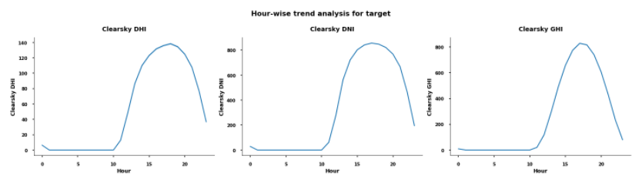

**Finding-2**: All target variables are 0 for Solar Zenith Angle >= 93 degrees. Another interesting discovery, which helped in reducing the training dataset size even further.

**Finding-3**: All target variables are highly correlated, and both DNI and GHI values are 0, when DHI = 0. I used this as a post-processing step, where anytime the model predicted DHI as 0, I defaulted the DNI and GHI also as 0.

